**Expansion and Technology Centralization Report**

Xenia H.

Data and Business Strategy Consultant

April 21, 2024

**Expansion and Technology Centralization Report**

In this enterprise-level report, we provide our findings and insights derived from an in-depth analysis of various datasets, aimed at addressing critical business questions surrounding ABC Company's expansion and technological centralization. Through meticulous examination and visualization of key metrics, we illuminate strategic pathways that enable ABC Company to navigate the complexities of the competitive landscape and drive sustainable growth. Join us as we delve into the transformative potential of data-driven decision-making in shaping the future trajectory of ABC Company.

## IT Help Desk

Through our analysis of ABC Company's IT Help Desk dataset, we've gleaned valuable insights into the efficiency of issue resolution processes and customer satisfaction levels. Leveraging Microsoft Power BI, we've identified several key findings.

Firstly, we found that Systems-related issues tickets are the most submitted with 40.04k tickets, as illustrated in Figure 1. Surprisingly, despite being the lowest ticket submitted, hardware-related issues rank first with the longest resolution times, averaging 17.31 days, as shown in Figure 2. This underscores the critical need for attention to hardware-related concerns within our IT infrastructure. Additionally, we've observed a correlation between ticket categories and resolution times, with systems-related issues exhibiting long resolution times (average of 9.52 days) compared to other categories such as software and access/login, as depicted in Figure 2.

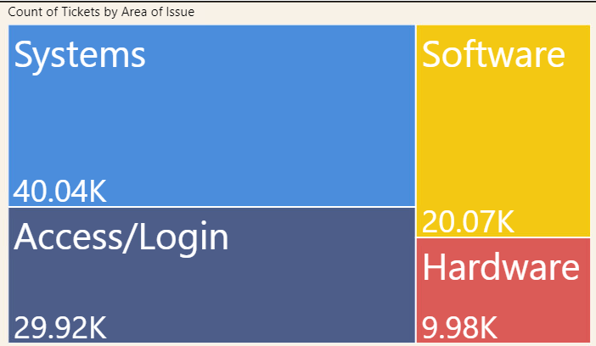

Figure 1: Count of Tickets by Area of Issue

Figure 2 : Average of Waiting Days by Issue.

Thirdly, high-priority tickets are resolved more expeditiously compared to low-priority ones, with an average resolution time of 5.93 days for high-priority tickets, 7.23 days for medium-priority tickets, and 8.52 days for low-priority tickets as shown in Figure 3.

These insights emphasize the importance of prioritizing high-priority tickets for efficient service delivery. Moreover, depicted in Figure 4 we can see there's a direct correlation between resolution times and customer satisfaction levels, with 21,124 tickets reported as unsatisfied and 19,602 tickets reported as satisfied.

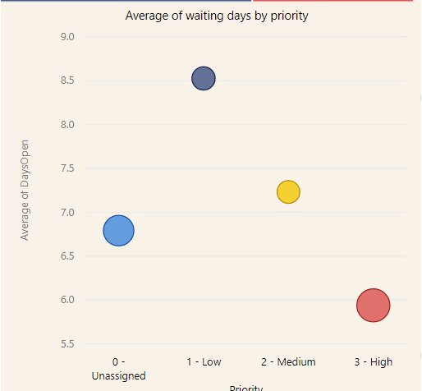

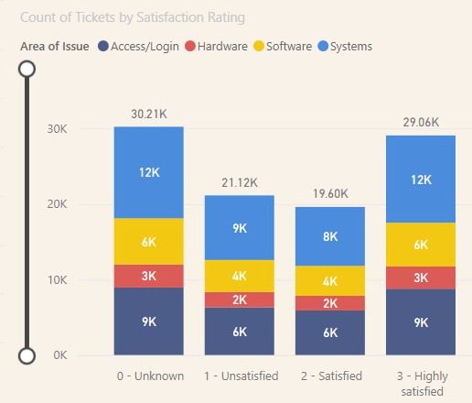 Figure 3: Average of waiting days by priority.

Figure 4: Count of Tickets by Satisfaction Rating

Lastly, analysis of workload distribution among IT owners revealed variations in individual performance and workload allocation, with 25 IT staff with less than the medium amount of tickets completed which is 2,000 as shown in figure 5, and 10 with more than 2,000 completed tickets. These insights will inform strategic decision-making to update issue resolution processes, prioritize high-priority tickets, and optimize workload distribution, ultimately enhancing the completion time of software and hardware issues and customer satisfaction levels at ABC Company's IT Help Desk.

Figure 5: Count of Tickets by IT Owner

## Employee Attrition

Expanding on our analysis, we delved into the Employee Attrition dataset to glean insights crucial for organizational strategies. Unlike our previous IT Help Desk operations examination, this dataset offers a unique perspective on employee retention and turnover rates, essential for effective human resource management. Laboratory technicians with 62 and sales executives with 57 emerged with the highest attrition rates, suggesting potential challenges within these roles, as presented in Figure 6. Surprisingly, employees who rarely traveled exhibited the highest attrition percentage at 65.82%, showed in Figure 7, indicating the need for *A graph with blue bars
*nuanced approaches to travel policies.

*Figure 6: Attrition count by job role.*

*Figure 7: Percentage of attrition by Travel Frequency*

Furthermore, disparities based on education level and gender unveiled nuanced dynamics. Employees with level 3 education showed the highest attrition at 99 employees, with male employees consistently exhibiting higher attrition rates across all education levels, as seen in Figure 8. Additionally, male laboratory technicians faced the highest attrition rates at 42 employees, depicted in Figure 9, highlighting role-specific challenges.

*Figure 8: Attrition count by Education and Gender*

*Figure 9: Attrition by Job Role and Gender*

Based on our analysis of this dataset, we recommend several proposals. Firstly, we propose developing role-specific retention strategies tailored to high-attrition positions like laboratory technicians, focusing on job design improvements and professional development opportunities. Secondly, improving travel policies to address unexpectedly high attrition rates among employees who rarely travel could include offering flexible travel options and incentives. Thirdly, implementing diversity and inclusion programs to promote equity across gender and education levels, alongside mentorship opportunities, can foster a more inclusive environment.

## Telco Customer Churn

Continuing with our analysis, another dataset we delved into focuses on customer churn and related factors within ABC Company. Through Power BI visualizations, we explored key metrics such as service subscriptions, demographics, tenure, and financial metrics to uncover insights that inform customer retention strategies. Among the 1,869 churned customers, 170 subscribed solely to internet service, 113 solely to phone service, and 1,586 had both internet and phone services as shown in Figure 10, indicating a higher churn rate among customers with dual-service subscriptions, necessitating targeted retention efforts.

Gender distribution among churned customers was balanced, with 939 females and 930 males, suggesting that gender may not significantly influence churn behavior within ABC Company's customer base as shown in Figure 11. Analyzing churn rates by customer tenure revealed notable trends, with one-year tenures exhibiting the highest churn rate at 61.99%, followed by two-year tenures at 51.68%, and three-year tenures at 47%, highlighting the vulnerability of newly acquired customers to churn shown in Figure 12.

*Figure 10: Customer Churn by Service Subscription*

* Figure 11: Churn by customer Gender*

In Figure 12, we can observe a comparison of average monthly charges between churned and non-churned customers showed a significant disparity, with churned customers having an average monthly charge of $74.40, higher than the $61.27 observed among customers who remained with the company, emphasizing the role of pricing in customer retention decisions.

* Figure 12: Monthly charges by Churn*

In conclusion, our analysis provides actionable insights for ABC Company to enhance customer retention and mitigate churn risk. Targeting customers with shorter tenures and addressing areas of dissatisfaction such as high monthly charges will improve service quality and customer satisfaction. Tactics like bundle offerings, segmented marketing, and incentivizing preferred payment methods will enable effective prediction of customer behavior and the development of focused retention programs, ensuring competitiveness in the market.

## Retail Sales and Marketing, Profit and Cost

Continuing with our analysis, we now turn our attention to the insights gleaned from the Retail Sales and Marketing, Profit, and Cost dataset. This dataset offers a comprehensive view of sales performance, product profitability, and cost-effectiveness within the retail sector, providing valuable insights to guide organizational strategies.

The exploration of this dataset revealed significant findings regarding sales revenue trends over time and the performance of various product lines. Specifically, in 2016, the company experienced its highest sales revenue, totaling $968,941,497, closely followed by 2017 with $936,474,226 in sales revenue as seen in Figure 13. These insights highlight the efficacy of marketing campaigns and sales strategies during these years.

Furthermore, delving into sales revenue by product line highlighted key categories driving overall sales performance. Figure 14 shows that "Personal Accessories" emerged as the top-performing product line, generating approximately $1.8 billion in revenue, followed closely by "Camping Equipment" with around $1.6 billion. These figures underscore the importance of these product lines in contributing to the company's revenue streams.

Additionally, the analysis of product profitability unveiled top-performing products in terms of gross profit. "Product Star Dome" emerged as the most profitable product, contributing $33,000,000 to gross profit, followed closely by "Product Hibernator Extreme" with a gross profit of $32,000,000, presented in Figure 15.

* Figure 13: Revenue by Year from 2013 to 2017*

* Figure 14: Revenue by Product Line*

Figure 15: Gross Profit by Product

While the insights from this dataset offer valuable information on sales performance and profitability, they do not directly link with the analyses conducted on the Telco Customer Churn, Employee Attrition, or IT Help Desk datasets. These datasets focus on distinct aspects of ABC Company's operations, ranging from customer churn behavior and employee retention to IT service quality and satisfaction.

Understanding the insights from the Retail Sales and Marketing, Profit, and Cost dataset is essential for ABC Company. It provides valuable information on revenue streams, product performance, and cost-effectiveness, enabling targeted strategies to enhance operational efficiency, refine marketing, optimize products, and allocate resources effectively. This understanding empowers ABC Company to drive revenue growth and improve customer satisfaction, and profitability in the competitive retail landscape.

## Marketing Campaign

Now shifting our focus to marketing campaign performance within ABC Company. Our examination of the marketing campaign dataset revealed intriguing patterns in sales performance across various metrics. Sales performance exhibited notable fluctuations across different market sizes and weeks.

Notably, Week 1 emerged as the most lucrative period across all market sizes, while Week 4 stood out with the highest sales in the small market size segment, reaching an impressive $58,000 (Figure 16). Market ID 3 consistently demonstrated its prowess as the top performer in generating sales, closely trailed by Market ID 10 and Market ID 5 (Figure 17). Remarkably, Week 1 maintained its dominance across all market IDs, suggesting a recurring trend in sales performance irrespective of market specifics.

*Figure 16: Average Sales by Market Size and Week Number*

*Figure 17: Sales in Thousands by Market ID and Week Number*

Furthermore, our analysis in Figure 18 highlighted the impact of promotional strategies on sales outcomes. Campaigns featuring Promotion 3 showcased exceptional success rates, with Week 2 recording the peak of sales. Conversely, Promotion 2 struggled to deliver, particularly evident in Week 4's lackluster performance.

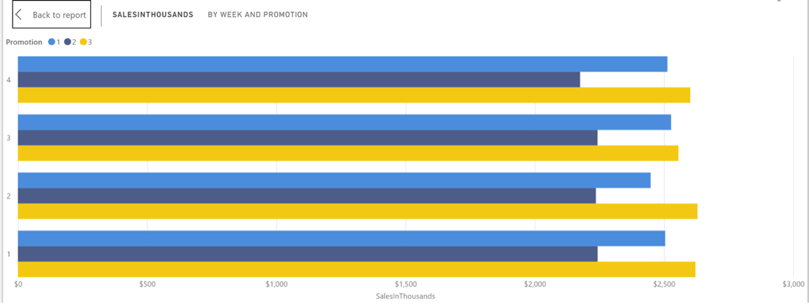

*Figure 18: Sales by Week Number and Promotion*

We found there is a significant correlation to the insights derived from the Retail Sales and Marketing, Profit, and Cost analysis. For instance, the examination of sales revenue over time in the Retail Sales and Marketing, Profit, and Cost dataset provides insights into the effectiveness of marketing campaigns and sales strategies, directly connecting with the objectives of the marketing campaign dataset. Similarly, the analysis of product profitability sheds light on the performance of specific products, which can inform promotional strategies and sales efforts.

Despite these correlations, it's essential to recognize that the Retail Sales and Marketing, Profit, and Cost dataset focuses on retail operations and financial metrics, whereas the marketing campaign dataset primarily centers on promotional strategies and sales outcomes. While interconnected, these datasets offer insights into different aspects of ABC Company's operations,

## Security Policies

Regarding the current IT infrastructure assessment, our analysis addresses the challenge faced by our company in integrating technology and information systems across its offices located in the North, South, East, and West regions of the United States. The current setup involves each territory operating independently with its technology infrastructure. To achieve organizational cohesion and efficiency, it is imperative to assess the existing IT infrastructure, identify areas for improvement, and propose strategic solutions tailored to each region's needs. This paper will outline the evaluation of the current IT setup in each territory and recommend appropriate measures to centralize technology resources and enhance collaboration.

Hardware Platform:

To improve upon the existing physical server hardware platform, transitioning to a cloud-based infrastructure would be advantageous. This shift would eliminate the need for on-premises hardware maintenance and reduce costs associated with managing multiple servers across different locations. Additionally, migrating to a cloud-based platform offers scalability and flexibility to accommodate future growth and technological advancements. Consolidating to one vendor for the cloud-based platform, such as Microsoft Azure or Amazon Web Services (AWS), would streamline management and support processes.

This combined approach ensures consistency in service delivery, simplifies troubleshooting, and enhances security protocols. As we're currently using HP across the business for hardware solutions, leveraging HP's Managed Device Services would be beneficial in this transition. HP's as-a-service model provides world-class devices and services through a flexible framework, aligning with our goals of optimizing IT performance while managing costs. HP's Managed Device Services simplify device lifecycle management, offering better employee experiences and improved security. Opting for Platform as a Service (PaaS) model, such as Microsoft Azure, also aligns with our strategy. This approach provides automatic software updates, built-in security features, and simplified development and deployment processes, enhancing overall efficiency and reducing operational complexities.

Business Systems:

The current business systems in place, including Lotus and various versions of Excel (2007, 2010, and 2016), may not be the most practical solution for unified data management and reporting. Lotus, while once widely used, has become outdated and lacks modern features and support.

Excel, while versatile, often leads to variations in reporting due to different versions being used across offices. Transitioning to Power BI as the proposed technology offers several advantages, including enhanced data visualization, real-time analytics, and interactive reporting capabilities. However, it's essential to consider whether Power BI is practical for all users, particularly those who may not be familiar with advanced data analysis tools. One potential challenge with transitioning solely to Power BI is ensuring compatibility with existing workflows and user preferences. Some users may have specialized reporting needs or workflows that are better suited to traditional spreadsheet-based tools like Excel.

Moreover, enforcing standardization and data governance practices across the organization may require additional effort and resources. To address these challenges, a phased approach to implementing Power BI could be considered. Providing comprehensive training and support to users transitioning from Excel to Power BI can help mitigate resistance to change and ensure a smooth transition. Additionally, offering alternative reporting solutions for users with specialized needs while gradually introducing Power BI for standard reporting tasks can help balance user requirements with the organization's strategic goals.

Security/Security Policy:

Given the diverse hardware platforms across the organization's locations, implementing a robust security strategy is imperative to mitigate potential risks. An effective solution is deploying Sophos Intercept X, a comprehensive endpoint protection platform renowned for its advanced threat detection capabilities and rapid response functionalities. Sophos Intercept X offers a breadth and depth of data needed to investigate and respond to suspicious activities effectively.

With features such as comprehensive logging of device activity and integration with Sophos Data Lake (Sophos, 2024), organizations gain critical insights into potential threats across multiple attack surfaces. Additionally, Live Discover empowers administrators to query devices and investigate activity in real time, while Live Response provides a secure terminal for remediation actions, ensuring swift incident response. (Sophos, 2024)

Besides this program implementation, we are also to implement policies overriding login credentials and passwords, stressing the use of strong passwords and regular updates. Moreover, stopping the use of removable media, such as DVDs and USBs, should be enforced, also keep including encryption protocols and device usage restrictions. Email attachment policies should be started to detect and block suspicious attachments, added by employee education on identifying phishing attempts.

Additionally, timeout policies should automatically lock inactive computers, while policies regulating the storage of personal pictures and documents should restrict access and implement encryption measures. It's essential to note that employees will not be permitted to act as system administrators on their computers, enhancing security measures.

Website:

The current decentralized approach to website management, with each site hosting its independent web presence and infrastructure, poses significant challenges for the organization's overarching digital strategy. This decentralized structure leads to fragmented online identities, hindering cohesive branding efforts and diluting the organization's online presence. Furthermore, managing multiple websites introduces complexities in administration, including the coordination of updates, security protocols, and hosting requirements across disparate platforms.

Given these challenges, consolidating the individual websites into a single unified platform is urgent to streamline administration and improve the organization's online presence and efficiency. Based on extensive research and industry reputation, I recommend leveraging the services of Amazon Web Services (AWS) for hosting the consolidated website.

AWS is a leading cloud service provider known for its robust infrastructure, reliability, and scalability. With a wide range of hosting solutions and advanced security features, AWS can effectively support the organization's needs for a consolidated and highly available web platform. Additionally, AWS offers comprehensive support services and a global network of data centers, ensuring optimal performance and reliability for the organization's online presence (What-is-aws, n.d.).

Operating Systems Platform:

The presence of a mix of Microsoft operating systems, ranging from Windows XP to Windows 10, poses several challenges for network administrators. Firstly, managing multiple operating systems requires additional resources and expertise, as each version may have unique configuration requirements and security vulnerabilities.

Secondly, compatibility issues may arise when trying to integrate systems and applications across different operating environments, leading to decreased efficiency and productivity. Additionally, the lack of consistent support and updates for older operating systems like Windows XP leaves systems exposed to potential security threats and compliance risks. To address these challenges, I recommend implementing a phased migration to Windows 10 across all systems.

This approach involves assessing the current infrastructure to identify compatibility issues and develop a migration plan that prioritizes critical systems and applications. It's essential to ensure compatibility with existing hardware and software and provide comprehensive training and support to end-users throughout the transition process. Leveraging automated deployment tools and centralized management solutions can streamline the migration process and minimize disruption to business operations.

By adopting Windows 10, network administrators can streamline management processes, enhance system reliability, and improve user experience. The transition will enable the organization to mitigate security risks, optimize productivity, and stay competitive in today's dynamic business landscape. (Why You Should Upgrade to Windows 10 - Microsoft Support, n.d.)

Reporting:

When it comes to reporting we must implement as few as possible programs or software because we need consistency across different departments, in this case, I believe that office administrators as well as data analysts and so, therefore I recommend using Power BI and Excel in their latest version, this is because with Power BI we can import datasets from Excel with ease, therefore leveraging the day to day activities by not taking so much time using different non-compatible programs.

Training is key here. We'll need to make sure everyone knows how to use the tools effectively. So, I propose we organize some training sessions to walk everyone through Power BI and Excel. And of course, we'll be there to provide ongoing support and help out whenever needed. By mixing things up with different reporting options and providing the right training, we can make sure everyone has what they need to work with data effectively. It's all about keeping things simple, and accessible, and empowering everyone to make the most of our data.

Management Concerns

As we move forward with our IT infrastructure enhancements, I want to assure you of our commitment to ensuring the security and integrity of our systems. By implementing enterprise-grade antivirus software like Sophos Intercept X, we are enhancing our ability to detect and respond to potential threats effectively. Sophos Intercept X offers advanced threat detection capabilities and rapid response functionalities, empowering our network administrators to safeguard our systems against evolving cyber threats (Sophos, 2024).

Additionally, enforcing strict security policies, such as password management and removable media restrictions, will further bolster our defenses and mitigate potential risks. Through these measures, along with continuous monitoring and compliance audits, I am confident that we can maintain a secure and resilient IT environment to support our business operations effectively.

Summary

I have outlined our strategy to optimize our IT infrastructure and information systems across our company's offices located in different regions of the United States. We discussed the importance of transitioning to cloud-based solutions, consolidating hardware platforms, and standardizing operating systems to enhance organizational cohesion and efficiency. By leveraging industry-leading solutions such as Microsoft Azure and Amazon Web Services (AWS) for cloud hosting, HP's Managed Device Services for hardware solutions, and Sophos Intercept X for endpoint protection, we aim to streamline management processes and enhance security protocols.

Furthermore, I recommended a phased approach to implementing Power BI for data analysis and reporting, complemented by Excel for administrative and non-analytical positions, ensuring user adoption and compatibility across departments. Through these strategic initiatives, we are poised to optimize our IT infrastructure, improve collaboration, and drive business growth securely and efficiently.

**Summary**

In this enterprise-level report, we have conducted a comprehensive analysis of various datasets to glean insights crucial for ABC Company's strategic decision-making. Our examination of the IT Help Desk dataset revealed the importance of prioritizing high-priority tickets and optimizing workload distribution to enhance operational efficiency and customer satisfaction levels. Delving into the Employee Attrition dataset highlighted the need for equity-focused initiatives tailored to laboratory technicians and sales executives, who emerged as the job roles with the highest turnover rates, to reduce turnover rates and foster a supportive work environment.

Insights from the Telco Customer Churn dataset emphasized the significance of targeted retention strategies to improve customer retention rates and drive revenue growth. Additionally, our analysis of the Retail Sales and Marketing, Profit, and Cost dataset underscored the importance of optimizing promotional strategies and focusing on top-performing product lines to maximize profitability.

By synthesizing these insights, we propose actionable recommendations for ABC Company's strategic initiatives:

1. Implement targeted training programs and support mechanisms for IT staff to address software-related issues efficiently and equitably distribute the workload.
2. Introduce mentorship programs and diversity training initiatives tailored to laboratory technicians and sales executives, the job roles with the highest turnover rates, to reduce turnover rates and foster a supportive work environment.
3. Develop personalized retention strategies for customers with shorter tenures and dissatisfaction areas to improve customer retention rates and drive revenue growth.
4. Focus promotional efforts on top-performing product lines to maximize revenue generation and enhance overall profitability.

By harnessing the power of data-driven insights and executing targeted strategies, ABC Company is poised to adapt and expand within the vibrant market panorama. These insights serve as a proposal for growth, guiding ABC Company for enduring success and strengthened market presence.

**References**

SOPHOS. (2024). Prevent Breaches, Ransomware, and Data Loss with Sophos Endpoint. sophos.com. https://www.sophos.com/en-us/products/endpoint-antivirus

what-is-aws. (n.d.). [Video]. Amazon Web Services, Inc. https://aws.amazon.com/what-is-aws/

Why you should upgrade to Windows 10 - Microsoft Support. (n.d.). https://support.microsoft.com/en-us/windows/why-you-should-upgrade-to-windows-10